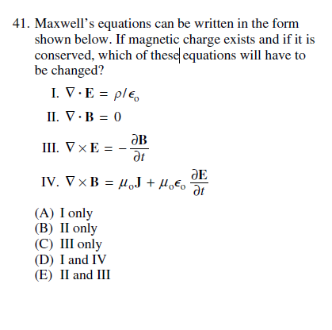

42. Three wire loops and an observer are positioned as shown in the figure above. From the observer’s
point of view, a current I flows counterclockwise in the middle loop, which is moving towards the
observer with a velocity u . Loops A and B are stationary. This same observer would notice that
(A) clockwise currents are induced in loops A and B
(B) counterclockwise currents are induced in loops A and B
(C) a clockwise current is induced in loop A, but a counterclockwise current is induced inloop B
(D) a counterclockwise current is induced in loop A, but a clockwise current is induced in loop B
(E) a counterclockwise current is induced in loop A, but no current is induced in loop B

